МИНИСТЕРСТВО НАУКИ И ВЫСШЕГО ОБРАЗОВАНИЯ РОССИЙСКОЙ ФЕДЕРАЦИИ
федеральное государственное бюджетное образовательное учреждение высшего образования «Российский экономический университет имени Г.В. Плеханова»
Московский приборостроительный техникум

ОТЧЕТ
по учебной практике
УП.04.01 Внедрение и поддержка программного обеспечения______ ________________________________________________________________.

Профессионального модуля ПМ.04 Сопровождение и обслуживание программного обеспечения компьютерных систем .

Специальность 09.02.07 Информационные системы и программирование ____________________________________________________________.

Студент Камышов Матвей Борисович.
(фамилия, имя, отчество)
Группа П50-2-20

Руководитель по практической подготовке от техникума

Серяк Даниил Владимирович.
(фамилия, имя, отчество)

«__» ______ 2023 года
Практическая работа №2
Работа с паттерном DAO
Цель работа: реализовать приложение на фреймворке «Spring», которое будет включать в себя работу с паттерном DAO.
Ход работы:
После создания проекта несколько папок и соответствующий файлы в них, а также «html» файлы.
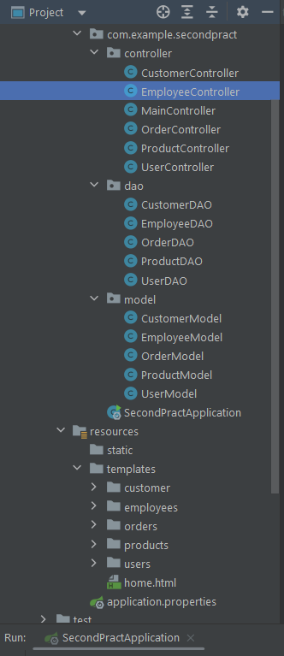
Рисунок 1 Файлы в проекте
Код «CustomerController»:

package com.example.secondpract.controller;

import com.example.secondpract.dao.CustomerDAO;
import com.example.secondpract.model.CustomerModel;
import org.springframework.beans.factory.annotation.Autowired;
import org.springframework.stereotype.Controller;
import org.springframework.ui.Model;
import org.springframework.web.bind.annotation.*;

@Controller
@RequestMapping("/customer")
public class CustomerController {

private CustomerDAO _customerDAO;

@Autowired
public CustomerController(CustomerDAO customerDAO) {
_customerDAO = customerDAO;
}

@GetMapping()
public String index(Model model) {
model.addAttribute("customer", _customerDAO.index());
return "customer/index";
}

@GetMapping("/{id}")
public String show(@PathVariable("id") int id, Model model) {
model.addAttribute("customer", _customerDAO.show(id));
return "customer/show";
}

@GetMapping("/new")
public String newCustomer(@ModelAttribute("customer") CustomerModel customerModel) {
return "customer/new";
}

@PostMapping()
public String createCustomer(@ModelAttribute("customer") CustomerModel customerModel) {
_customerDAO.save(customerModel);
return "redirect:/customer";
}

@GetMapping("/{id}/edit")
public String edit(Model model, @PathVariable("id") int id) {
model.addAttribute("customer", _customerDAO.show(id));
return "customer/edit";
}

@PostMapping("/update/{id}")
public String updateCustomer(@ModelAttribute("customer") CustomerModel customerModel, @PathVariable("id") int id) {
_customerDAO.update(id, customerModel);
return "redirect:/customer";
}

@PostMapping("/delete/{id}")
public String deleteCustomer(@PathVariable("id") int id) {
_customerDAO.delete(id);
return "redirect:/customer";
}
}

Код «EmployeeController»:

package com.example.secondpract.controller;

import com.example.secondpract.dao.EmployeeDAO;
import com.example.secondpract.model.EmployeeModel;
import org.springframework.beans.factory.annotation.Autowired;
import org.springframework.stereotype.Controller;
import org.springframework.ui.Model;
import org.springframework.web.bind.annotation.*;

@Controller
@RequestMapping("/employees")
public class EmployeeController {

private EmployeeDAO _employeeDAO;

@Autowired
public EmployeeController(EmployeeDAO employeeDAO) {
_employeeDAO = employeeDAO;
}

@GetMapping()
public String index(Model model) {
model.addAttribute("employees", _employeeDAO.index());
return "employees/index";
}

@GetMapping("/{id}")
public String show(@PathVariable("id") int id, Model model) {
model.addAttribute("employee", _employeeDAO.show(id));
return "employees/show";
}

@GetMapping("/new")
public String newEmployee(@ModelAttribute("employee") EmployeeModel employeeModel) {
return "employees/new";
}

@PostMapping()
public String createEmployee(@ModelAttribute("employee") EmployeeModel employeeModel) {
_employeeDAO.save(employeeModel);
return "redirect:/employees";
}

@GetMapping("/{id}/edit")
public String edit(Model model, @PathVariable("id") int id) {
model.addAttribute("employee", _employeeDAO.show(id));
return "employees/edit";
}

@PostMapping("/update/{id}")
public String updateEmployee(@ModelAttribute("employee") EmployeeModel employeeModel, @PathVariable("id") int id) {
_employeeDAO.update(id, employeeModel);
return "redirect:/employees";
}

@PostMapping("/delete/{id}")
public String deleteEmployee(@PathVariable("id") int id) {
_employeeDAO.delete(id);
return "redirect:/employees";
}
}

Код «MainController»:

package com.example.secondpract.controller;

import org.springframework.stereotype.Controller;
import org.springframework.web.bind.annotation.GetMapping;

@Controller
public class MainController {
@GetMapping("/")
String getHome(){
return "home";
}
}

Код «OrderController»:

package com.example.secondpract.controller;

import com.example.secondpract.dao.OrderDAO;
import com.example.secondpract.model.OrderModel;
import org.springframework.beans.factory.annotation.Autowired;
import org.springframework.stereotype.Controller;
import org.springframework.ui.Model;
import org.springframework.web.bind.annotation.*;

@Controller
@RequestMapping("/orders")
public class OrderController {

private OrderDAO _orderDAO;

@Autowired
public OrderController(OrderDAO orderDAO) {
_orderDAO = orderDAO;
}

@GetMapping()
public String index(Model model) {
model.addAttribute("orders", _orderDAO.index());
return "orders/index";
}

@GetMapping("/{id}")
public String show(@PathVariable("id") int id, Model model) {
model.addAttribute("order", _orderDAO.show(id));
return "orders/show";
}

@GetMapping("/new")
public String newOrder(@ModelAttribute("order") OrderModel orderModel) {
return "orders/new";
}

@PostMapping()
public String createOrder(@ModelAttribute("order") OrderModel orderModel) {
_orderDAO.save(orderModel);
return "redirect:/orders";
}

@GetMapping("/{id}/edit")
public String edit(Model model, @PathVariable("id") int id) {
model.addAttribute("order", _orderDAO.show(id));
return "orders/edit";
}

@PostMapping("/update/{id}")
public String updateOrder(@ModelAttribute("order") OrderModel orderModel, @PathVariable("id") int id) {
_orderDAO.update(id, orderModel);
return "redirect:/orders";
}

@PostMapping("/delete/{id}")
public String deleteOrder(@PathVariable("id") int id) {
_orderDAO.delete(id);
return "redirect:/orders";
}
}

Код «ProductController»:

package com.example.secondpract.controller;

import com.example.secondpract.dao.ProductDAO;
import com.example.secondpract.model.ProductModel;
import org.springframework.beans.factory.annotation.Autowired;
import org.springframework.stereotype.Controller;
import org.springframework.ui.Model;
import org.springframework.web.bind.annotation.*;

@Controller
@RequestMapping("/products")
public class ProductController {

private ProductDAO _productDAO;

@Autowired
public ProductController(ProductDAO productDAO) {
_productDAO = productDAO;
}

@GetMapping()
public String index(Model model) {
model.addAttribute("products", _productDAO.index());
return "products/index";
}

@GetMapping("/{id}")
public String show(@PathVariable("id") int id, Model model) {
model.addAttribute("product", _productDAO.show(id));
return "products/show";
}

@GetMapping("/new")
public String newProduct(@ModelAttribute("product") ProductModel productModel) {
return "products/new";
}

@PostMapping()
public String createProduct(@ModelAttribute("product") ProductModel productModel) {
_productDAO.save(productModel);
return "redirect:/products";
}

@GetMapping("/{id}/edit")
public String edit(Model model, @PathVariable("id") int id) {
model.addAttribute("product", _productDAO.show(id));
return "products/edit";
}

@PostMapping("/update/{id}")
public String updateProduct(@ModelAttribute("product") ProductModel productModel, @PathVariable("id") int id) {
_productDAO.update(id, productModel);
return "redirect:/products";
}

@PostMapping("/delete/{id}")
public String deleteProduct(@PathVariable("id") int id) {
_productDAO.delete(id);
return "redirect:/products";
}
}

Код «UserController»:

package com.example.secondpract.controller;

import com.example.secondpract.dao.UserDAO;
import com.example.secondpract.model.UserModel;
import org.springframework.beans.factory.annotation.Autowired;
import org.springframework.stereotype.Controller;
import org.springframework.ui.Model;
import org.springframework.web.bind.annotation.*;

@Controller
@RequestMapping("/users")
public class UserController {

private UserDAO _userDAO;

@Autowired
public UserController(UserDAO userDAO) {
_userDAO = userDAO;
}

@GetMapping()
public String index(Model model) {
model.addAttribute("users", _userDAO.index());
return "users/index";
}

@GetMapping("/{id}")
public String show(@PathVariable("id") int id, Model model) {
model.addAttribute("user", _userDAO.show(id));
return "users/show";
}

@GetMapping("/new")
public String newUser(@ModelAttribute("user") UserModel userModel) {
return "users/new";
}

@PostMapping()
public String createUser(@ModelAttribute("user") UserModel userModel) {
_userDAO.save(userModel);
return "redirect:/users";
}

@GetMapping("/{id}/edit")
public String edit(Model model, @PathVariable("id") int id) {
model.addAttribute("user", _userDAO.show(id));
return "users/edit";
}

@PostMapping("/update/{id}")
public String updateUser(@ModelAttribute("user") UserModel userModel, @PathVariable("id") int id) {
_userDAO.update(id, userModel);
return "redirect:/users";
}

@PostMapping("/delete/{id}")
public String deleteUser(@PathVariable("id") int id) {
_userDAO.delete(id);
return "redirect:/users";
}
}

Код «CustomerDAO»:

package com.example.secondpract.dao;

import com.example.secondpract.model.CustomerModel;
import org.springframework.stereotype.Component;

import java.util.ArrayList;
import java.util.List;
@Component
public class CustomerDAO {
private static int CUSTOMER_COUNT;
private List<CustomerModel> customer;

{
customer = new ArrayList<>();

customer.add(new CustomerModel(++CUSTOMER_COUNT, "John", "Doe", "123 Main St"));
customer.add(new CustomerModel(++CUSTOMER_COUNT, "Jane", "Smith", "456 Oak St"));
customer.add(new CustomerModel(++CUSTOMER_COUNT, "On", "Smith", "452 Oak St"));
customer.add(new CustomerModel(++CUSTOMER_COUNT, "Bob", "Johnson", "789 Maple St"));
}

public List<CustomerModel> index() {
return customer;
}

public CustomerModel show(int id) {
return customer.stream().filter(customer -> customer.getId() == id).findAny().orElse(null);
}

public void save(CustomerModel Customer) {
Customer.setId(++CUSTOMER_COUNT);
customer.add(Customer);
}

public void update(int id, CustomerModel customerModel) {
CustomerModel updateCustomer = show(id);
updateCustomer.setFirstName(customerModel.getFirstName());
updateCustomer.setLastName(customerModel.getLastName());
updateCustomer.setAddress(customerModel.getAddress());
}

public void delete(int id) {
customer.removeIf(c -> c.getId() == id);
}
}

Код «EmployeeDAO»:

package com.example.secondpract.dao;

import com.example.secondpract.model.EmployeeModel;
import org.springframework.stereotype.Component;

import java.util.ArrayList;
import java.util.List;

@Component
public class EmployeeDAO {
private static int EMPLOYEE_COUNT;
private List<EmployeeModel> employees;

{
employees = new ArrayList<>();

employees.add(new EmployeeModel(++EMPLOYEE_COUNT, "John Doe", "Manager", 50000.0));
employees.add(new EmployeeModel(++EMPLOYEE_COUNT, "Jane Smith", "Developer", 60000.0));
employees.add(new EmployeeModel(++EMPLOYEE_COUNT, "Bob Johnson", "Designer", 55000.0));
employees.add(new EmployeeModel(++EMPLOYEE_COUNT, "Umar OI", "Developer", 60000.0));
}

public List<EmployeeModel> index() {
return employees;
}

public EmployeeModel show(int id) {
return employees.stream().filter(employee -> employee.getId() == id).findAny().orElse(null);
}

public void save(EmployeeModel employee) {
employee.setId(++EMPLOYEE_COUNT);
employees.add(employee);
}

public void update(int id, EmployeeModel employeeModel) {
EmployeeModel updateEmployee = show(id);
updateEmployee.setName(employeeModel.getName());
updateEmployee.setPosition(employeeModel.getPosition());
updateEmployee.setSalary(employeeModel.getSalary());
}

public void delete(int id) {
employees.removeIf(e -> e.getId() == id);
}
}

Код «OrderDAO»:

package com.example.secondpract.dao;

import com.example.secondpract.model.OrderModel;
import org.springframework.stereotype.Component;

import java.util.ArrayList;
import java.util.List;

@Component
public class OrderDAO {
private static int ORDER_COUNT;
private List<OrderModel> orders;

{
orders = new ArrayList<>();

orders.add(new OrderModel(++ORDER_COUNT, 1, 2, 69.98));
orders.add(new OrderModel(++ORDER_COUNT, 2, 1, 49.99));
orders.add(new OrderModel(++ORDER_COUNT, 1, 2, 69.98));
orders.add(new OrderModel(++ORDER_COUNT, 2, 1, 49.99));
}

public List<OrderModel> index() {
return orders;
}

public OrderModel show(int id) {
return orders.stream().filter(order -> order.getId() == id).findAny().orElse(null);
}

public void save(OrderModel order) {
order.setId(++ORDER_COUNT);
orders.add(order);
}

public void update(int id, OrderModel orderModel) {
OrderModel updateOrder = show(id);
updateOrder.setProductId(orderModel.getProductId());
updateOrder.setQuantity(orderModel.getQuantity());
updateOrder.setTotalPrice(orderModel.getTotalPrice());
}

public void delete(int id) {
orders.removeIf(o -> o.getId() == id);
}
}

Код «ProductDAO»:

package com.example.secondpract.dao;

import com.example.secondpract.model.ProductModel;
import org.springframework.stereotype.Component;

import java.util.ArrayList;
import java.util.List;

@Component
public class ProductDAO {
private static int PRODUCT_COUNT;
private List<ProductModel> products;

{
products = new ArrayList<>();

products.add(new ProductModel(++PRODUCT_COUNT, "Product1", 29.99, "Category1"));
products.add(new ProductModel(++PRODUCT_COUNT, "Product2", 39.99, "Category2"));
products.add(new ProductModel(++PRODUCT_COUNT, "Product3", 19.99, "Category1"));
products.add(new ProductModel(++PRODUCT_COUNT, "Product4", 49.99, "Category3"));
}

public List<ProductModel> index() {
return products;
}

public ProductModel show(int id) {
return products.stream().filter(product -> product.getId() == id).findAny().orElse(null);
}

public void save(ProductModel product) {
product.setId(++PRODUCT_COUNT);
products.add(product);
}

public void update(int id, ProductModel productModel) {
ProductModel updateProduct = show(id);
updateProduct.setProductName(productModel.getProductName());
updateProduct.setPrice(productModel.getPrice());
updateProduct.setCategory(productModel.getCategory());
}

public void delete(int id) {
products.removeIf(p -> p.getId() == id);
}
}

Код «UserDAO»:

package com.example.secondpract.dao;

import com.example.secondpract.model.UserModel;
import org.springframework.stereotype.Component;

import java.util.ArrayList;
import java.util.List;

@Component
public class UserDAO {
private static int USER_COUNT;
private List<UserModel> user;
{
user = new ArrayList<>();

user.add(new UserModel(++USER_COUNT,"perchik228", "perchik228@mail.ru", "qwerty123"));
user.add(new UserModel(++USER_COUNT,"seledka24", "seledka24@mail.ru", "zaxscd123"));
user.add(new UserModel(++USER_COUNT,"gnom123", "gnom123@mail.ru", "qwe123"));
user.add(new UserModel(++USER_COUNT,"meet444", "meet444@mail.ru", "asd123"));
}

public List<UserModel> index(){

return user;
}

public UserModel show(int id){
return user.stream().filter(UserModel -> UserModel.getId() == id).findAny().orElse(null);
}

public void save(UserModel User){
User.setId(++USER_COUNT);
user.add(User);
}

public void update(int id, UserModel userModel){
UserModel updateUser = show(id);
updateUser.setUsername(userModel.getUsername());
updateUser.setEmail(userModel.getEmail());
updateUser.setPassword(userModel.getPassword());
}

public void delete(int id){
user.removeIf(p-> p.getId() == id);
}
}

Код «CustomerModel»:

package com.example.secondpract.model;

public class CustomerModel {
private int _id;
private String _firstName;
private String _lastName;
private String _address;

public CustomerModel() {
}

public CustomerModel(int id, String firstName, String lastName, String address) {
_id = id;
_firstName = firstName;
_lastName = lastName;
_address = address;
}

public int getId() {
return _id;
}

public String getFirstName() {
return _firstName;
}

public String getLastName() {
return _lastName;
}

public String getAddress() {
return _address;
}

public void setId(int id) {
this._id = id;
}

public void setFirstName(String firstName) {
this._firstName = firstName;
}

public void setLastName(String lastName) {
this._lastName = lastName;
}

public void setAddress(String address) {
this._address = address;
}
}

Код «EmployeeModel»:

package com.example.secondpract.model;

public class EmployeeModel {
private int _id;
private String _name;
private String _position;
private double _salary;

public EmployeeModel() {}

public EmployeeModel(int id, String name, String position, double salary) {
_id = id;
_name = name;
_position = position;
_salary = salary;
}

public int getId() {
return _id;
}

public void setId(int id) {
this._id = id;
}

public String getName() {
return _name;
}

public void setName(String name) {
this._name = name;
}

public String getPosition() {
return _position;
}

public void setPosition(String position) {
this._position = position;
}

public double getSalary() {
return _salary;
}

public void setSalary(double salary) {
this._salary = salary;
}
}

Код «OrderModel»:

package com.example.secondpract.model;

public class OrderModel {
private int _id;
private int _productId;
private int _quantity;
private double _totalPrice;

public OrderModel() {}

public OrderModel(int id, int productId, int quantity, double totalPrice) {
_id = id;
_productId = productId;
_quantity = quantity;
_totalPrice = totalPrice;
}

public int getId() {
return _id;
}

public void setId(int id) {
this._id = id;
}

public int getProductId() {
return _productId;
}

public void setProductId(int productId) {
this._productId = productId;
}

public int getQuantity() {
return _quantity;
}

public void setQuantity(int quantity) {
this._quantity = quantity;
}

public double getTotalPrice() {
return _totalPrice;
}

public void setTotalPrice(double totalPrice) {
this._totalPrice = totalPrice;
}
}

Код «ProductModel»:

package com.example.secondpract.model;

public class ProductModel {
private int _id;
private String _productName;
private double _price;
private String _category;

public ProductModel() {}

public ProductModel(int id, String productName, double price, String category) {
_id = id;
_productName = productName;
_price = price;
_category = category;
}

public String getProductName() {
return _productName;
}

public void setProductName(String productName) {
this._productName = productName;
}

public int getId() {
return _id;
}

public void setId(int id) {
this._id = id;
}

public double getPrice() {
return _price;
}

public void setPrice(double price) {
this._price = price;
}

public String getCategory() {
return _category;
}

public void setCategory(String category) {
this._category = category;
}
}

Код «UserModel»:

package com.example.secondpract.model;

public class UserModel {

private int _id;
private String _username;
private String _email;
private String _password;

public UserModel(){}

public UserModel(int id, String username, String email, String password){
_id = id;
_username = username;
_email = email;
_password = password;
}

public String getUsername() {
return _username;
}

public void setUsername(String username) {
this._username = username;
}

public int getId() {
return _id;
}

public void setId(int id) {
this._id = id;
}

public String getEmail() {
return _email;
}

public void setEmail(String email) {
this._email = email;
}

public String getPassword() {
return _password;
}

public void setPassword(String password) {
this._password = password;
}
}

Код «home.html»:

<!DOCTYPE html>
<html lang="en">

<head>
<meta charset="UTF-8">
<meta name="viewport" content="width=device-width, initial-scale=1.0">
<title>Домашняя страница</title>
<style>
body {
font-family: 'Arial', sans-serif;
background-color: #f8f8f8;
margin: 0;
padding: 0;
color: #333;
}

header {
background-color: #e0e0e0;
padding: 10px;
text-align: center;
}

nav {
background-color: #d0d0d0;
padding: 10px;
text-align: center;
}

nav a {
text-decoration: none;
color: #555;
padding: 10px;
margin: 5px;
border-radius: 5px;
background-color: #c0c0c0;
transition: background-color 0.3s ease;
}

nav a:hover {
background-color: #b0b0b0;
}
</style>
</head>

<body>
<header>
<h1>Домашняя страница</h1>
</header>

<nav>
<a href="/customer">Заказчики</a>
<a href="/employees">Сотрудники</a>
<a href="/orders">Заказы</a>
<a href="/products">Продукты</a>
<a href="/users">Пользователи</a>
</nav>

<!-- Your content goes here -->

</body>

</html>

Код «edit.html»:

<!DOCTYPE html>
<html lang="en">

<head>
<meta charset="UTF-8">
<title>Title</title>
<style>
body {
font-family: 'Arial', sans-serif;
background-color: #f8f8f8;
margin: 0;
padding: 0;
color: #333;
text-align: center;
}

form {
background-color: #e0e0e0;
padding: 20px;
border-radius: 8px;
width: 300px;
margin: 50px auto;
}

label {
display: block;
margin-top: 10px;
color: #555;
}

input {
width: 100%;
padding: 8px;
margin-top: 5px;
margin-bottom: 10px;
box-sizing: border-box;
}

input[type="submit"] {
background-color: #c0c0c0;
color: #333;
border: none;
padding: 10px;
border-radius: 5px;
cursor: pointer;
transition: background-color 0.3s ease;
}

input[type="submit"]:hover {
background-color: #b0b0b0;
}
</style>
</head>

<body>

<form method="POST" th:method="PATCH" th:action="@{/customer/update/{id}(id = ${customer.getId()})}" th:object="${customer}">
<label for="firstName">Введите имя</label>
<input type="text" id="firstName" th:field="*{firstName}">
<label for="lastName">Введите фамилию</label>
<input type="text" id="lastName" th:field="*{lastName}">
<label for="address">Введите адрес</label>
<input type="text" id="address" th:field="*{address}">
<input type="submit" value="Update">
</form>

</body>

</html>

Код «index.html»:

<!DOCTYPE html>
<html lang="en" xmlns:th="http://www.thymeleaf.org">

<head>
<meta charset="UTF-8">
<title>Все заказчики</title>
<style>
body {
font-family: 'Arial', sans-serif;
background-color: #f8f8f8;
margin: 0;
padding: 0;
color: #333;
text-align: center;
}

h2 {
color: #444;
}

table {
width: 80%;
margin: 20px auto;
border-collapse: collapse;
}

th, td {
border: 1px solid #ddd;
padding: 10px;
text-align: left;
}

th {
background-color: #e0e0e0;
}

a {
text-decoration: none;
color: #007BFF;
font-weight: bold;
margin-right: 5px;
}

a.new-customer-link {
display: block;
margin-top: 20px;
background-color: #007BFF;
color: #fff;
padding: 10px;
border-radius: 8px;
text-decoration: none;
transition: background-color 0.3s ease;
}

a.new-customer-link:hover {
background-color: #0056b3;
}
</style>
</head>

<body>

<h2>Список заказчиков</h2>
<table>
<thead>
<tr>
<th>Имя</th>
<th>Фамилия</th>
<th>Адрес</th>
</tr>
</thead>
<tbody>
<tr th:each="cust: ${customer}">
<td><a th:href="@{/customer/{id}(id=${cust.getId()})}" th:text="${cust.getFirstName()}"></a></td>
<td><span th:text="${cust.getLastName()}"></span></td>
<td><span th:text="${cust.getAddress()}"></span></td>
</tr>
</tbody>
</table>

<a class="new-customer-link" href="/customer/new">Добавить нового заказчика</a>

</body>

</html>

Код «new.html»:

<!DOCTYPE html>
<html lang="en" xmlns:th="http://www.thymeleaf.org">

<head>
<meta charset="UTF-8">
<title>Title</title>
<style>
body {
font-family: 'Arial', sans-serif;
background-color: #f8f8f8;
margin: 0;
padding: 0;
color: #333;
text-align: center;
}

form {
background-color: #e0e0e0;
padding: 20px;
border-radius: 8px;
width: 300px;
margin: 50px auto;
}

label {
display: block;
margin-top: 10px;
color: #555;
}

input {
width: 100%;
padding: 8px;
margin-top: 5px;
margin-bottom: 10px;
box-sizing: border-box;
}

input[type="submit"] {
background-color: #007BFF;
color: #fff;
border: none;
padding: 10px;
border-radius: 5px;
cursor: pointer;
transition: background-color 0.3s ease;
}

input[type="submit"]:hover {
background-color: #0056b3;
}
</style>
</head>

<body>

<form th:method="POST" th:action="@{/customer}" th:object="${customer}">
<label for="firstName">Введите имя</label>
<input type="text" id="firstName" th:field="*{firstName}">

<label for="lastName">Введите фамилию</label>
<input type="text" id="lastName" th:field="*{lastName}">

<label for="address">Введите адрес</label>
<input type="text" id="address" th:field="*{address}">

<input type="submit" value="Create">
</form>

</body>

</html>

Код «show.html»:

<!DOCTYPE html>
<html lang="en" xmlns:th="http://www.thymeleaf.org">

<head>
<meta charset="UTF-8">
<title>Детали клиента</title>
<style>
body {
font-family: 'Arial', sans-serif;
background-color: #f8f8f8;
margin: 0;
padding: 0;
color: #333;
text-align: center;
}

.customer-info {
margin: 10px 0;
}

label {
display: block;
font-weight: bold;
margin-bottom: 5px;
}

p {
margin: 10px 0;
}

a {
text-decoration: none;
color: #007BFF;
font-weight: bold;
margin-right: 5px;
}

form {
margin-top: 20px;
display: inline-block;
}

input[type="submit"] {
background-color: #dc3545;
color: #fff;
border: none;
padding: 8px 12px;
border-radius: 5px;
cursor: pointer;
transition: background-color 0.3s ease;
}

input[type="submit"]:hover {
background-color: #c82333;
}
</style>
</head>

<body>

<div class="customer-info">
<label>Идентификатор клиента:</label>
<p th:text="${customer.getId()}"></p>
</div>

<div class="customer-info">
<label>Имя:</label>
<p th:text="${customer.getFirstName()}"></p>
</div>

<div class="customer-info">
<label>Фамилия:</label>
<p th:text="${customer.getLastName()}"></p>
</div>

<div class="customer-info">
<label>Адрес:</label>
<p th:text="${customer.getAddress()}"></p>
</div>

<a th:href="@{/customer/{id}/edit(id=${customer.getId()})}">Редактировать</a>

<form method="POST" th:method="DELETE" th:action="@{/customer/delete/{id}(id=${customer.getId()})}">
<input type="submit" value="УДАЛИТЬ">
</form>

</body>

</html>

Коды «html» файлов других листов идентичны и в них ничего особо не менялось, кроме темы.
Результат работы:
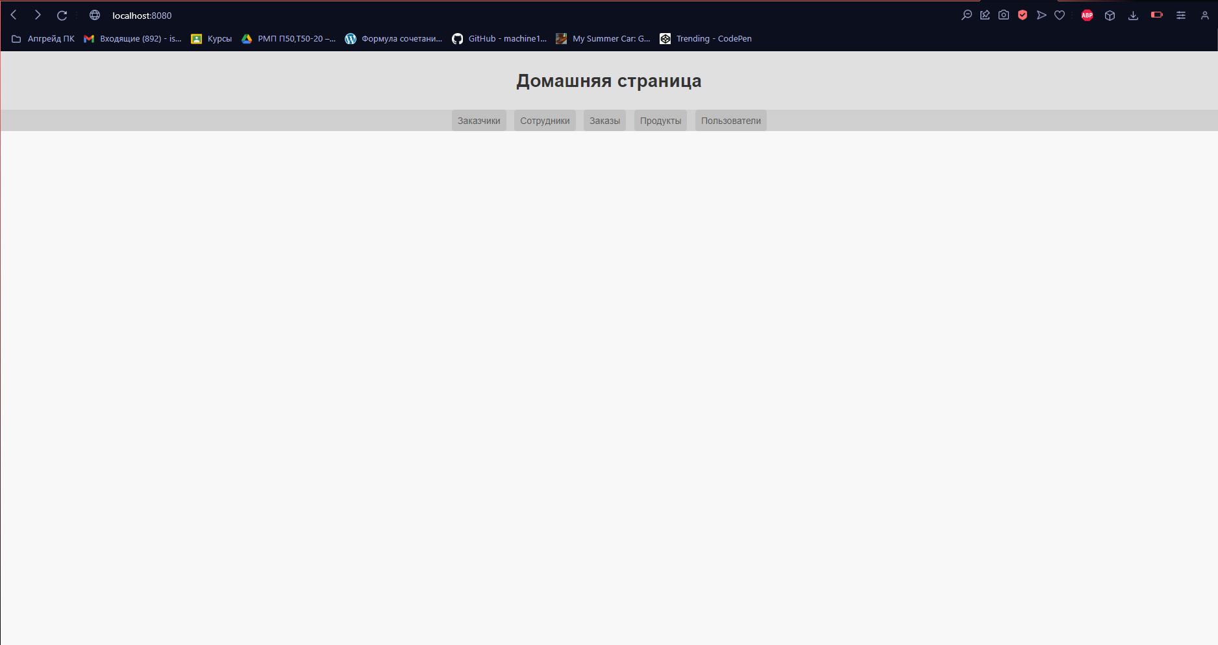
Рисунок 2 Домашняя страница
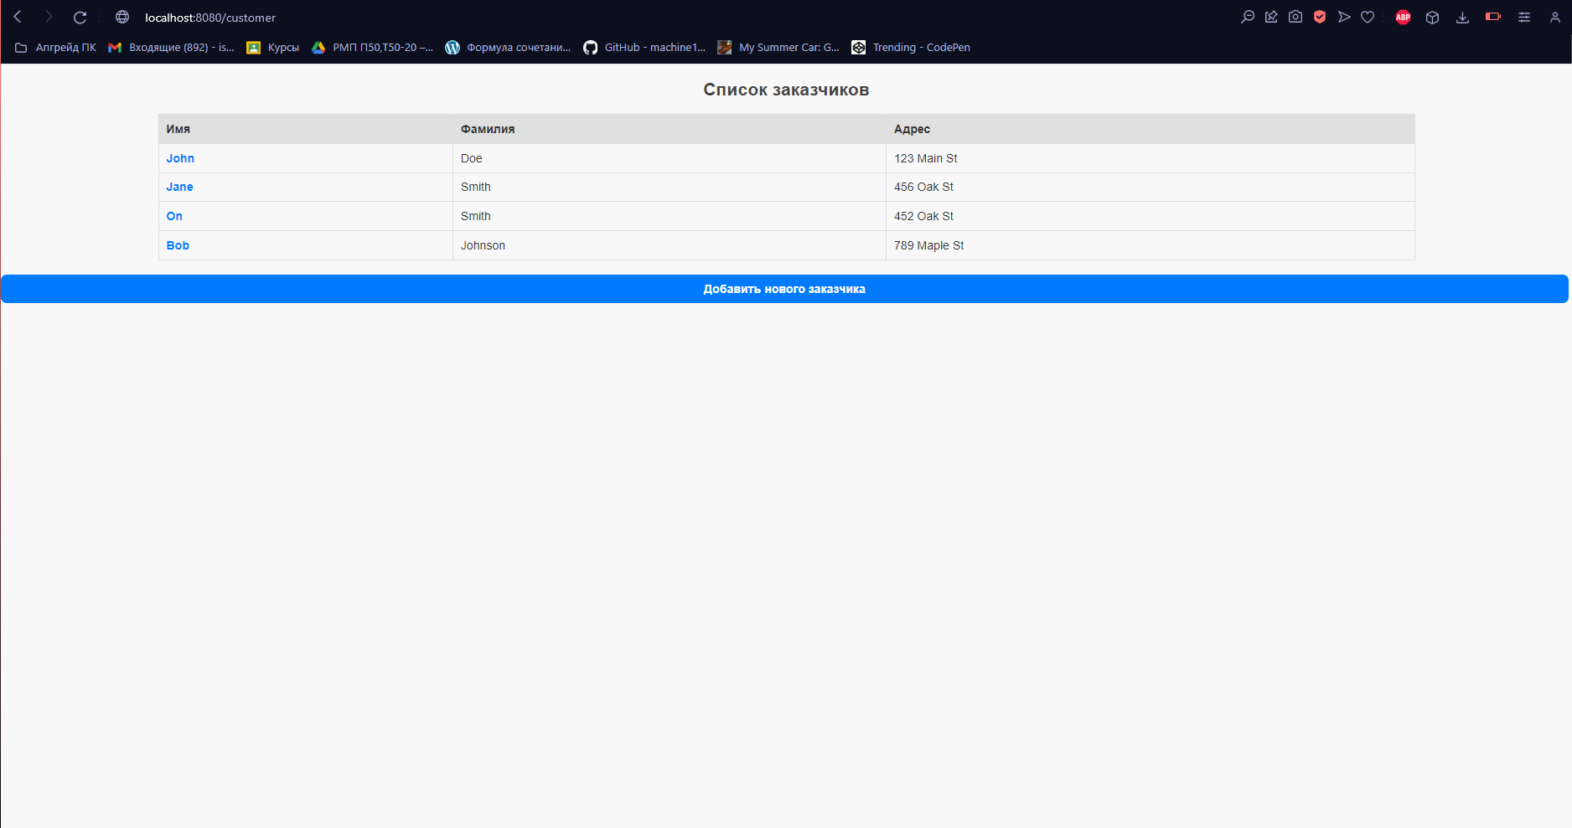
Рисунок 3 Вывод всех заказчиков
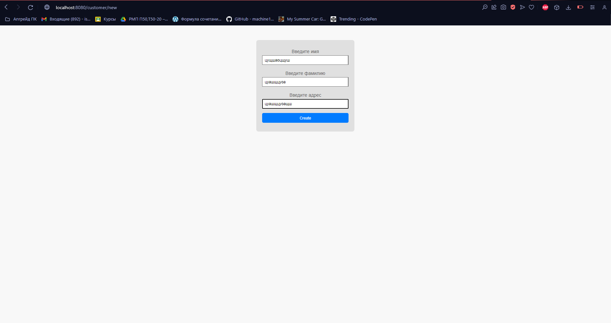
Рисунок 4 Добавление нового заказчика
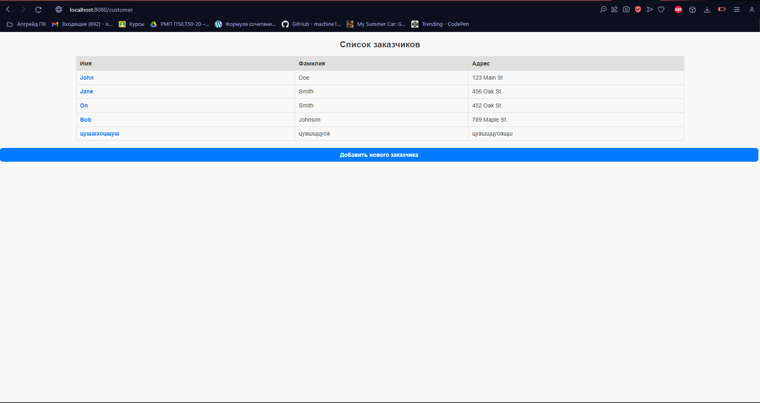
Рисунок 5 Заказчик добавлен
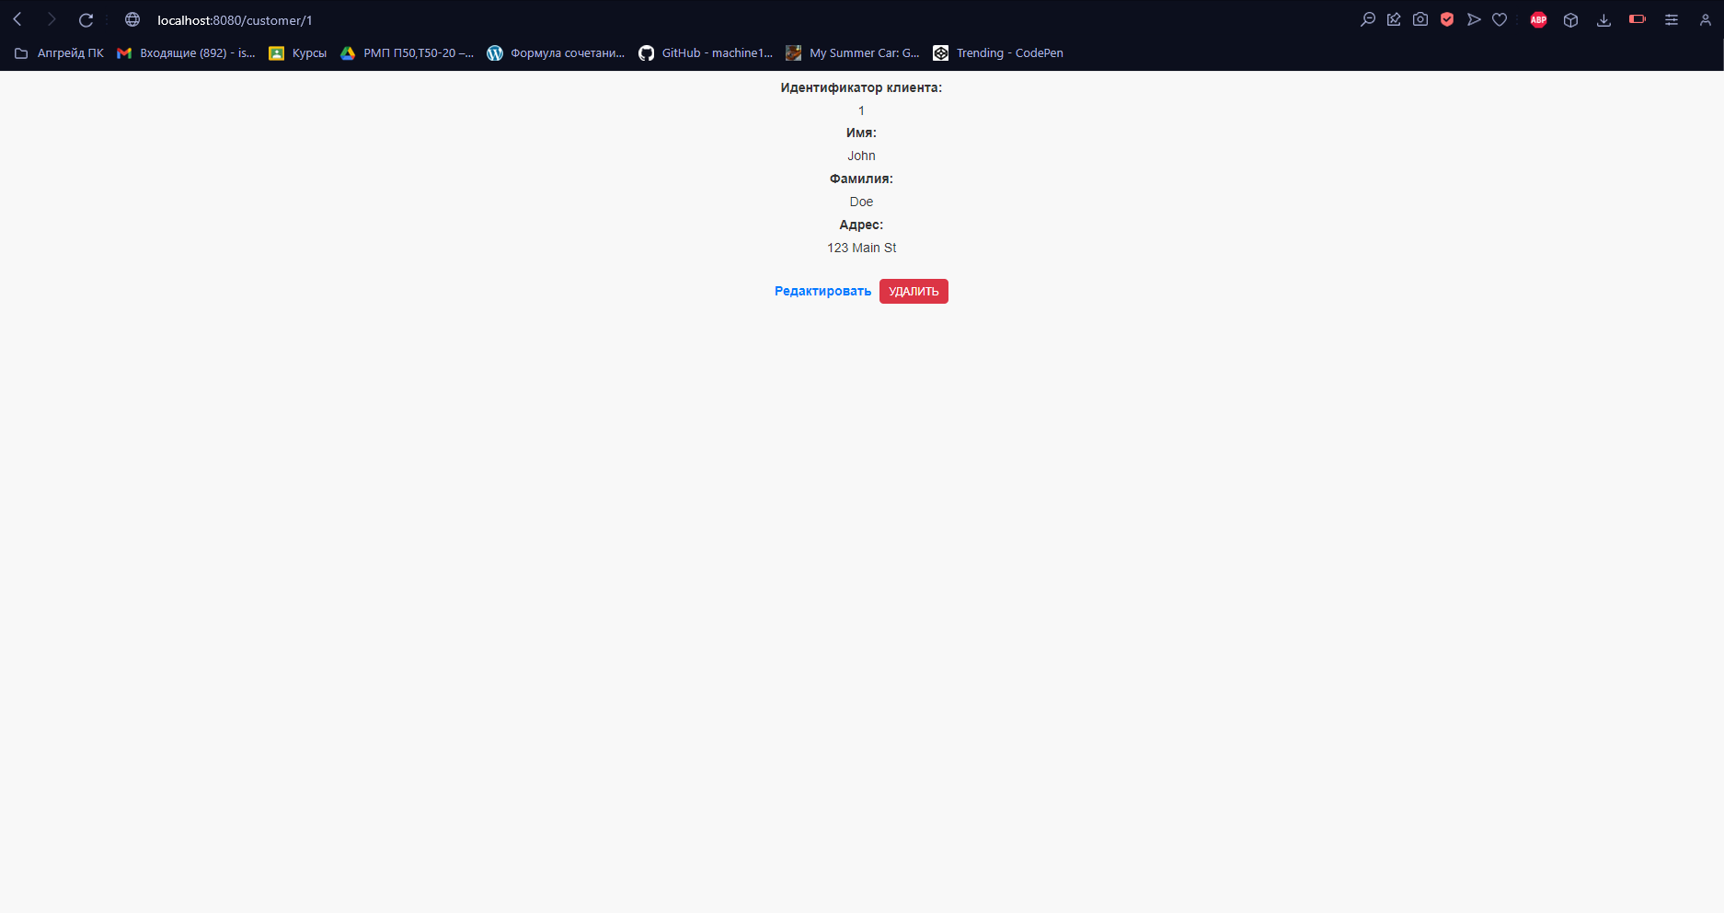
Рисунок 6 Подробная информация о заказчике
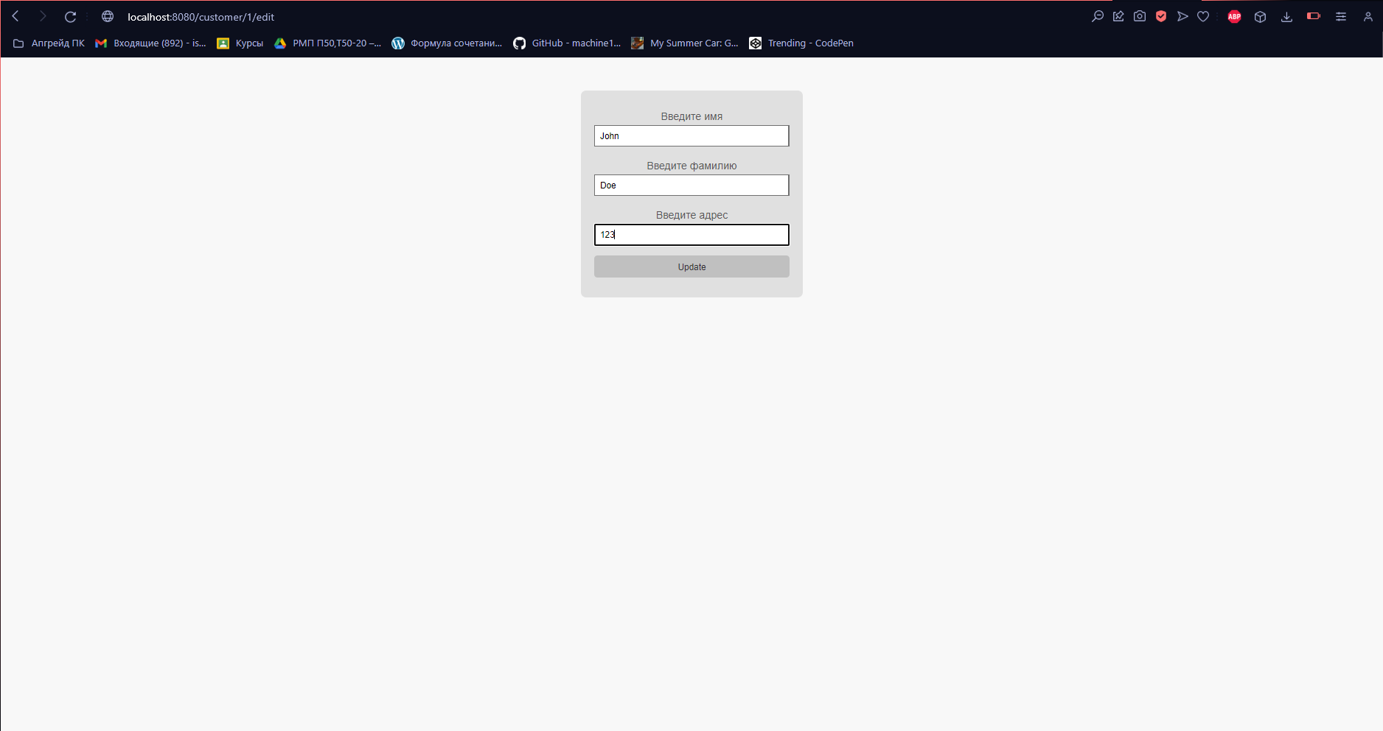
Рисунок 7 Изменение данных о заказчике
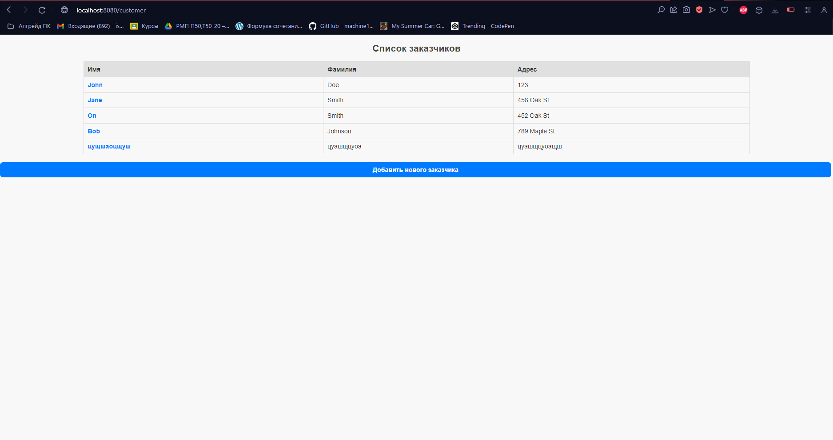
Рисунок 8 Данные изменены
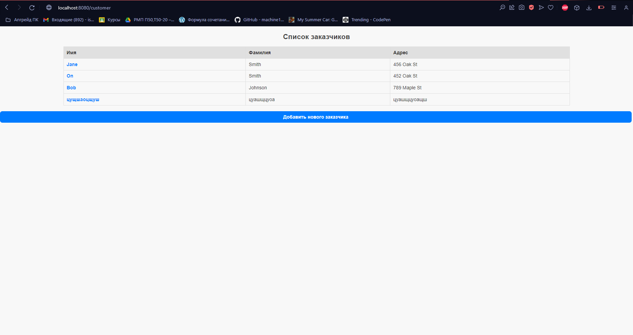
Рисунок 9 Заказчик удален
Вывод: в ходе выполнения практической работы реализовано приложение с использованием паттерна DAO.

